Movie Ticket Booking System

- View All Movies:
Default Menu: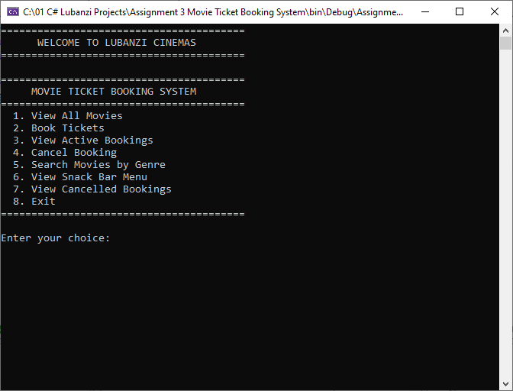

Viewing Option 1: 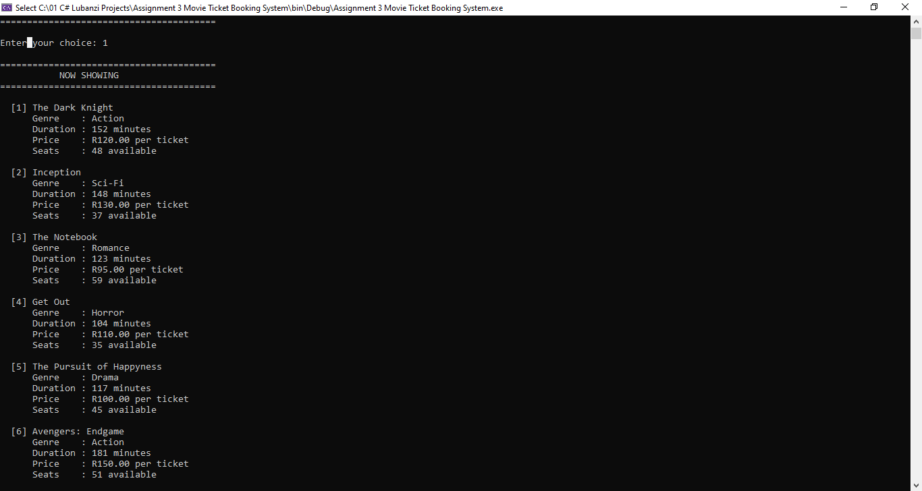
There’s a total of 7 movies availbe the last is Intersteller.

- Booking Tickets
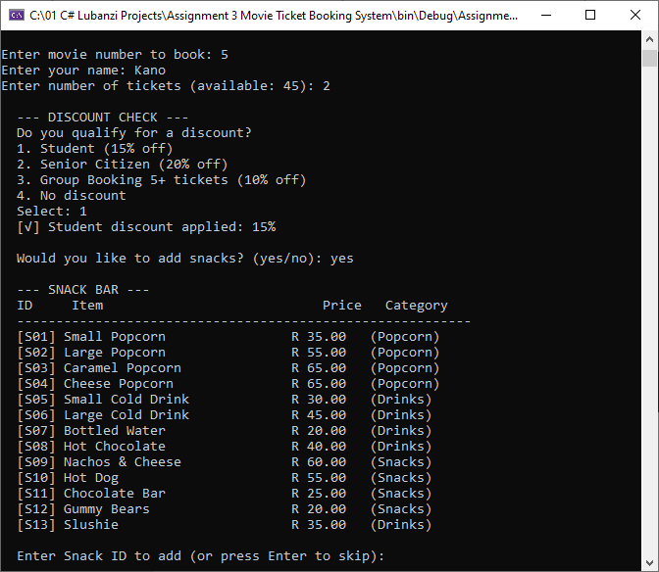
As you can see above, I booked movie number 5, and identified myself as a student which made me qualify for a 15% Discount.

Below I will choose the following snacks; 2x Caramel popcorns and 2x Large cold drinks/sodas.
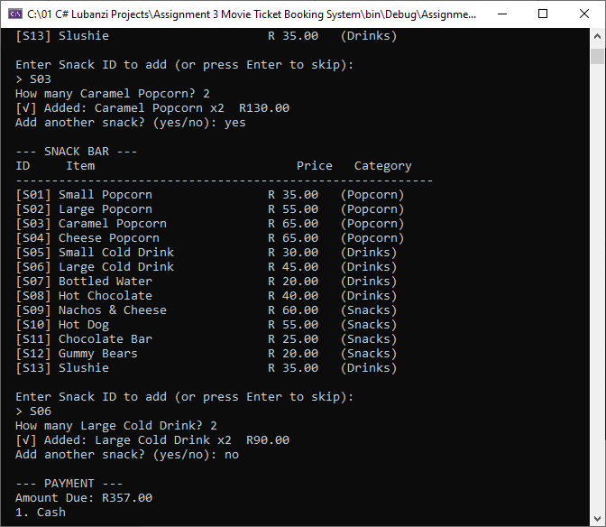

Now I will choose my payment method which is a card payment method:
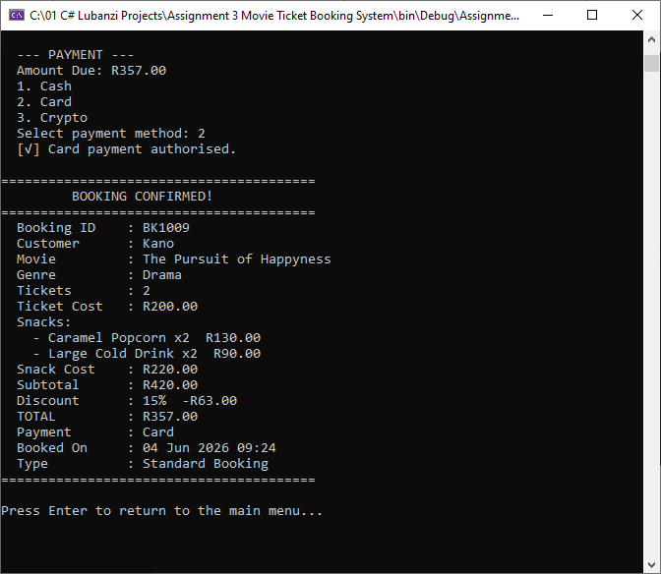
- View My Bookings
Below are screenshots that show movies booked and snacks ordered as well as the number of tickets purchased per person.
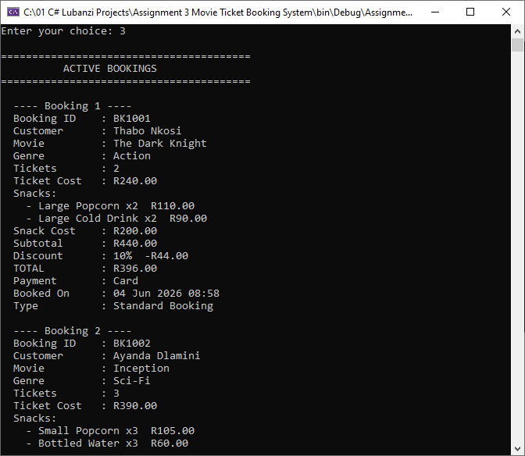
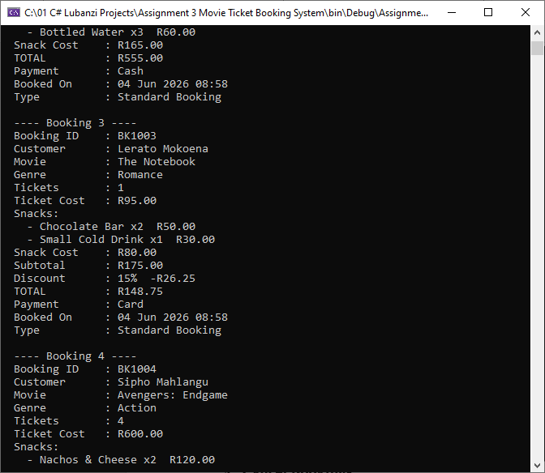
There’s a total of 6 bookings.
- Cancel Bookings:
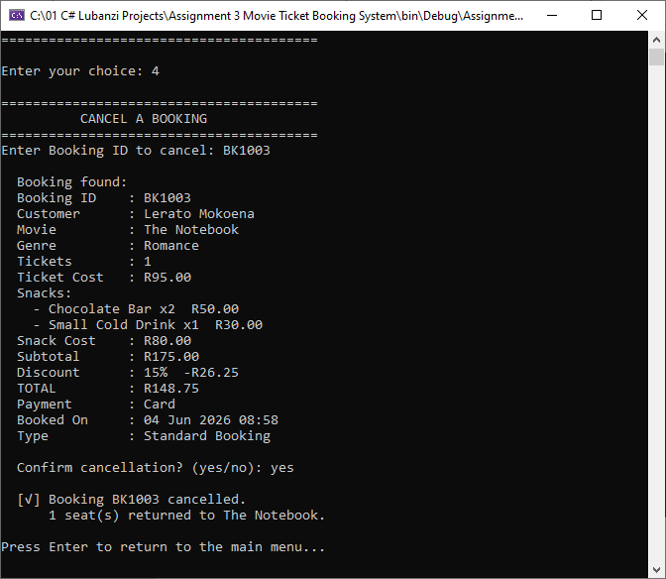
- Search Movies by Genre:
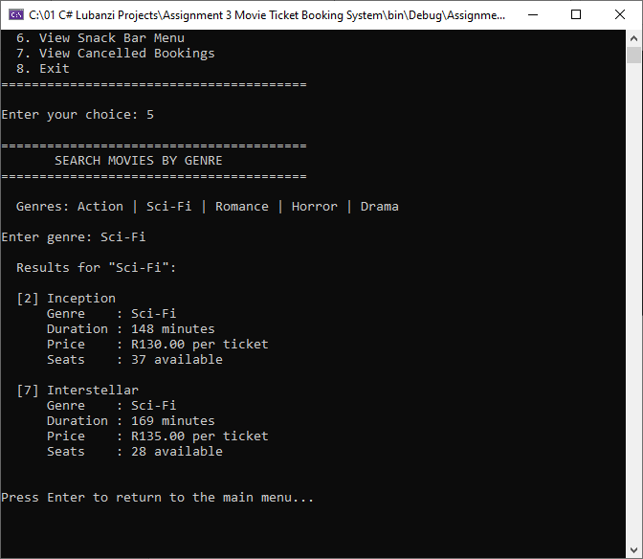
- View Snack Bar Menu:
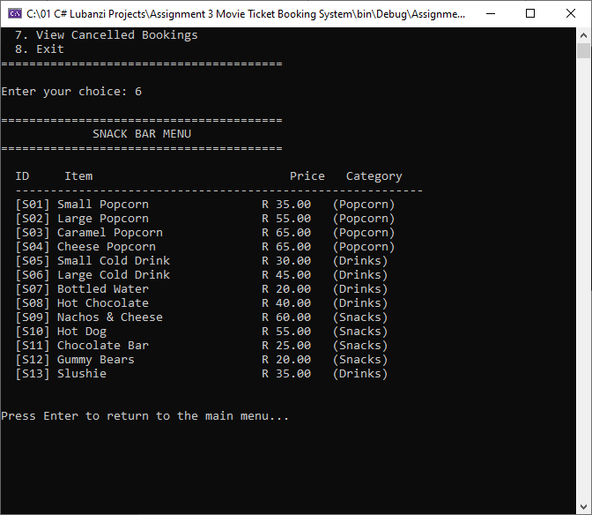
- View all cancelled bookings:
There’s a total of 4 cancelled bookings:
